**Assignment 2**

**PRN -: 22510063**

**Batch -: T4**

**Date of creation -: 25-01-2025**

**I. MySQL / PSM Review :**

**a) Create a table called test_table with 2 columns RecordNumber**

**(type : Number(3)) and CurrentDate (type : Date)). Write a**

**procedure in PSM which will insert 50 records into test_table. Insert**

**the current date value into the table.**

Input -:

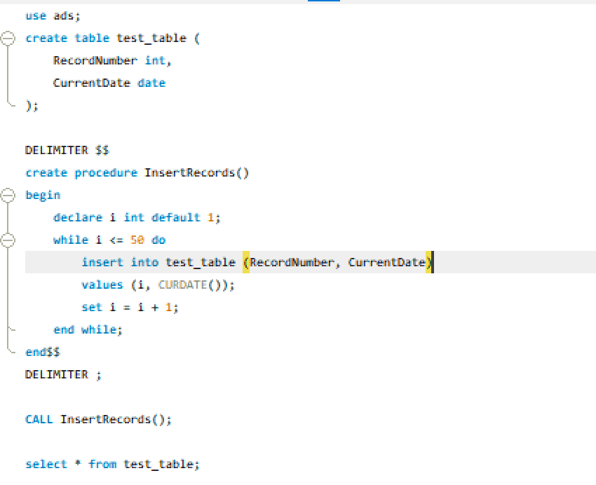

Output -:

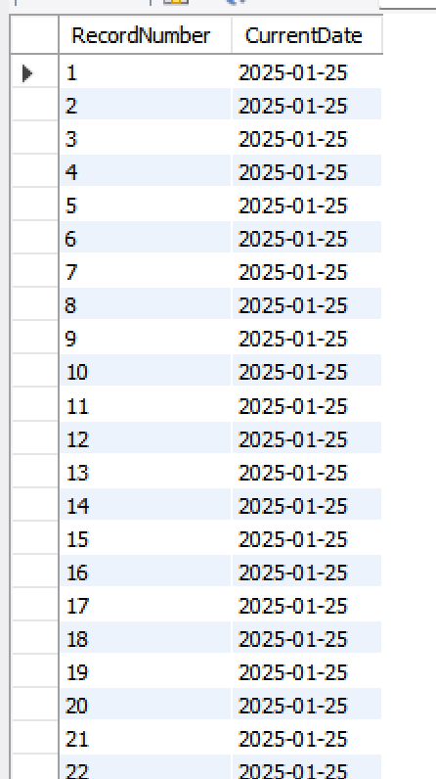

**b) Create a products table products(ProductID number(4),category**

**char(3),detail varchar2(30),price number(10,2),stock number(5)).**

**Insert the sample data.**

**Write PSM procedure with two arguments X & Y which will increase**

**price by X% for all products in category Y. X and Y will be given by**

**user.**

Input -:  
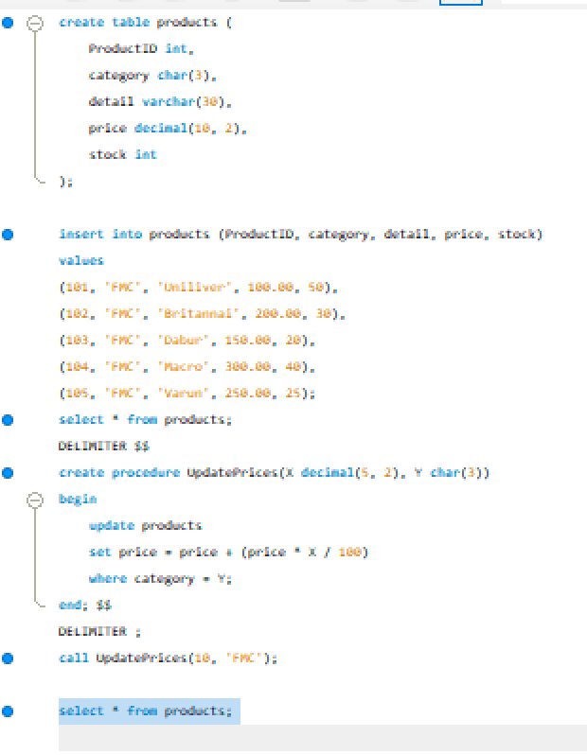

Output -: Table earlier

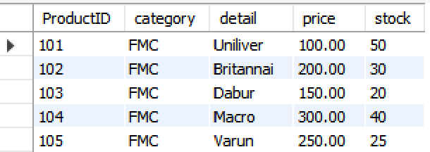

Table after performing the procedure

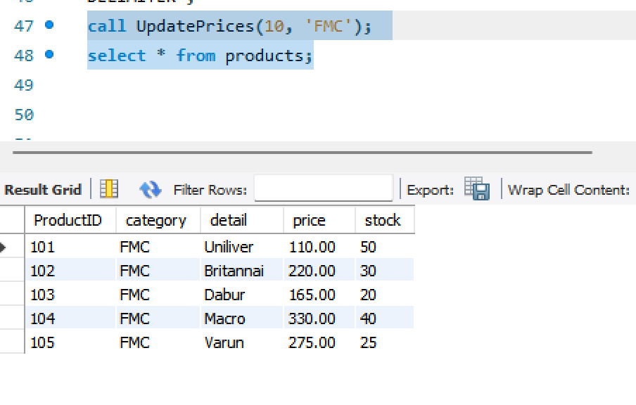

**II. Object Relational Databases:**

**a) Create Object Table containing field “name” of size 50**

**characters and member function “countNoOfWords” which**

**returns the no. of words in “name” field.**

**Demonstrate the working by entering different data.**

Step 1 -; creation of object type

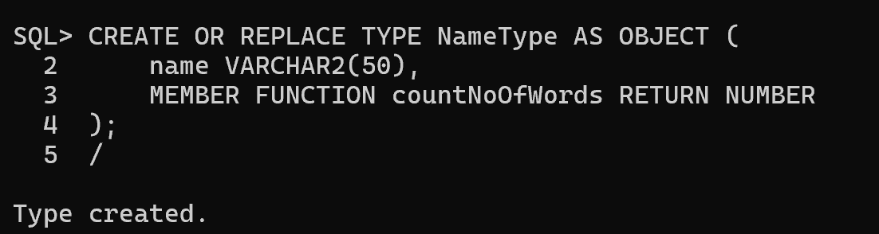

Step 2 -: Define the member function

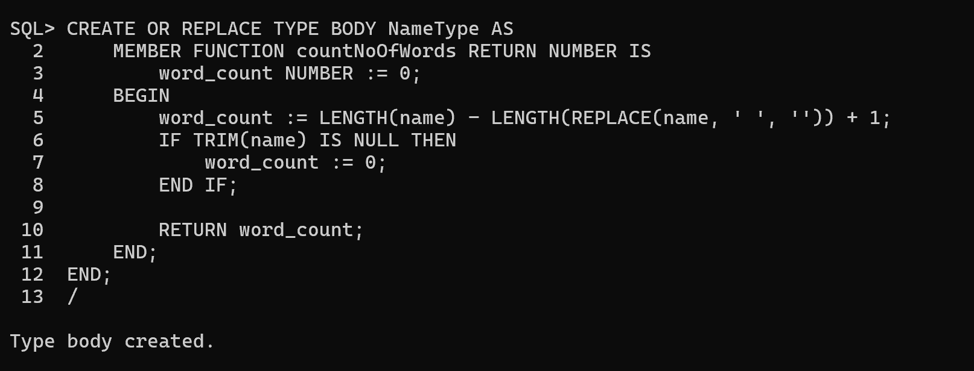

Step 3 -: Create the object table

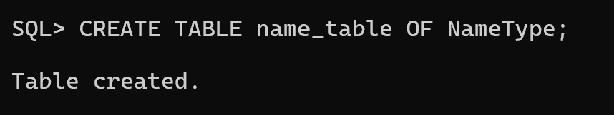

Step 4 -: Insert the sample data

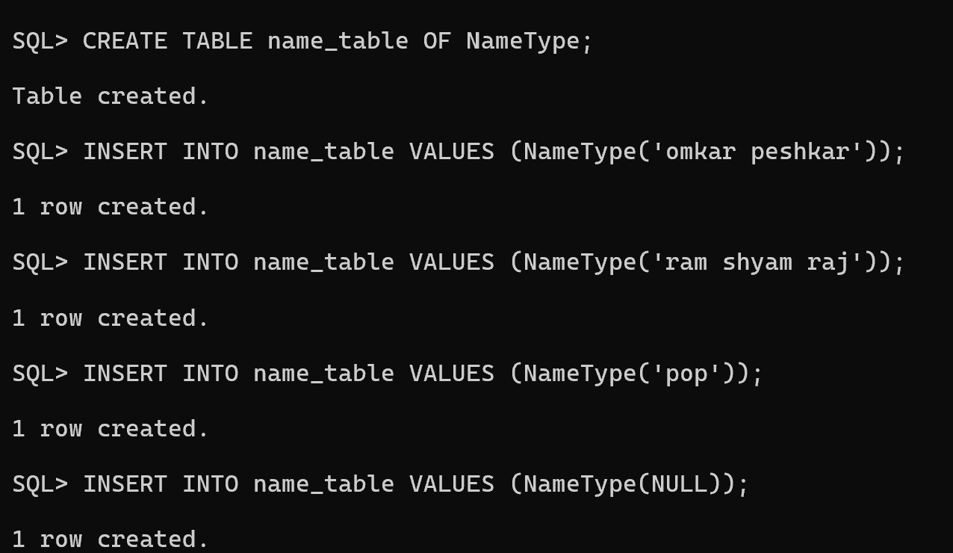

Step 5 -: Query the table and use the membership function

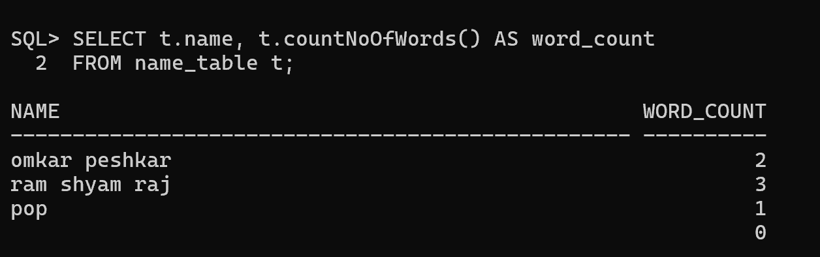

**b) Create an address type with the following attributes : address,**

**city, state & pincode. Include the following methods**

**i. to extract the addresses based on given keyword.**

**j. to return the no. of words in each given field (method**

**should accept the name of attribute/field)**

Step 1 -: Create the object type

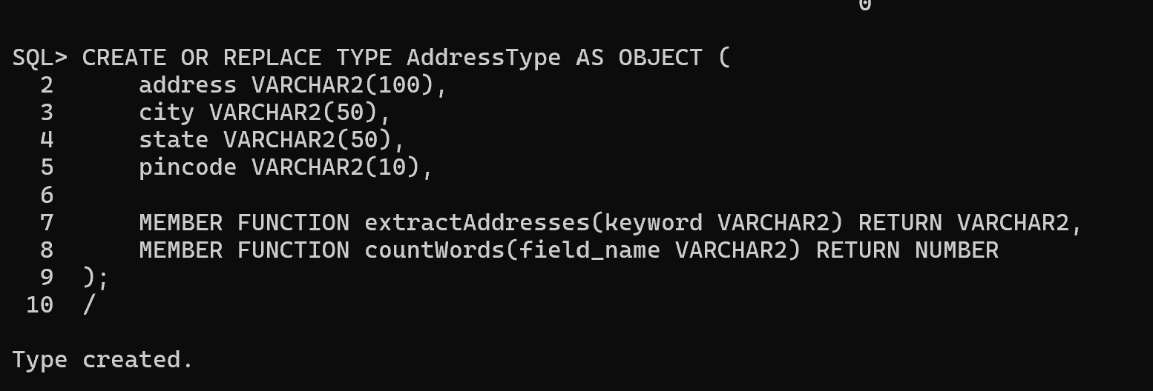

Step 2 -: Define the object type body

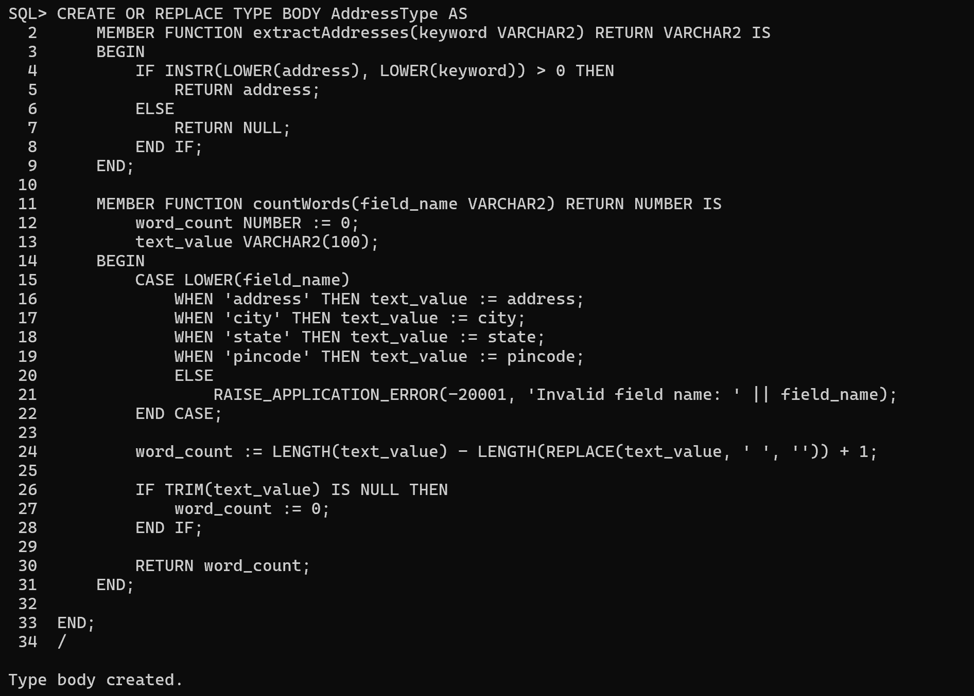

Step 3 -: Create an object table

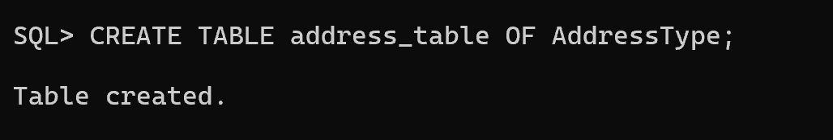

Step 4 -: Insert sample data



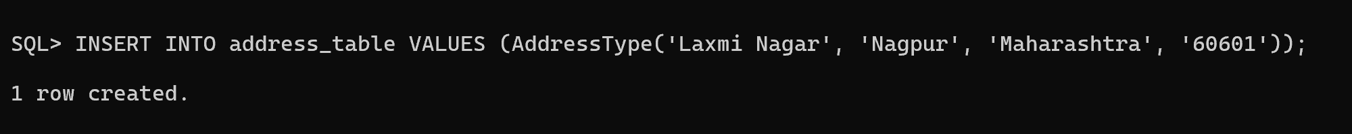

Output -:

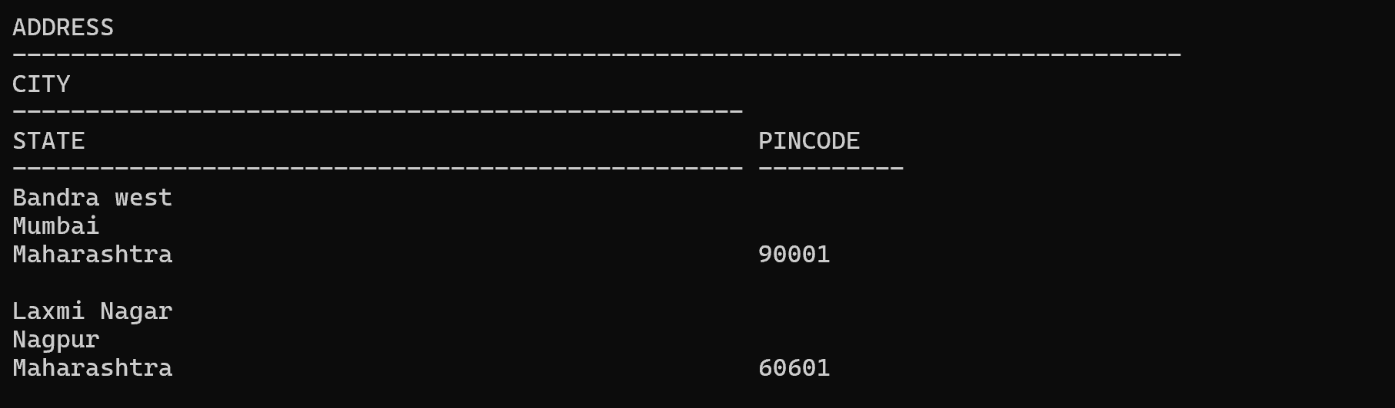  
Extract address based on keyword

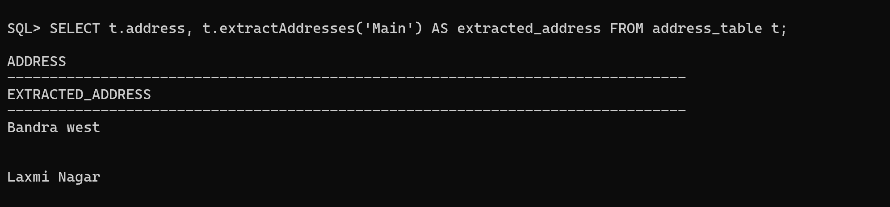

Count the number of words in specified field

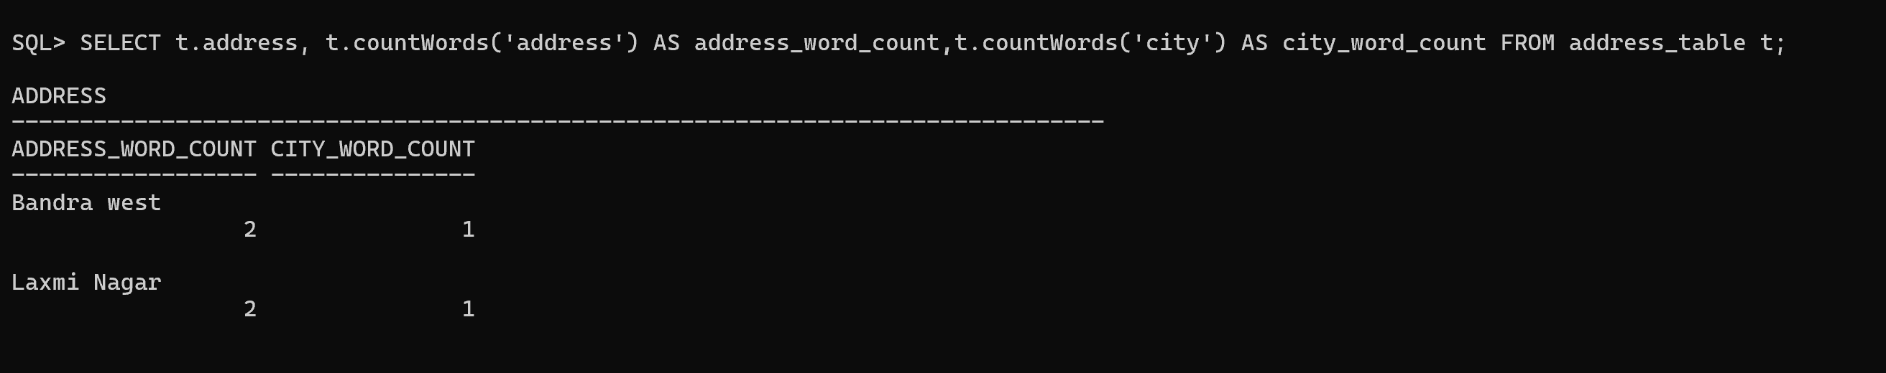

**c) Create a user defined data type course_Type with 2 attributes**

**course_id, description :**

**i. Create an object table based on the type created.**

**j. Insert rows into the table**

**Demonstrate the working with different data sets**

Step 1: Create the User-Defined Data Type

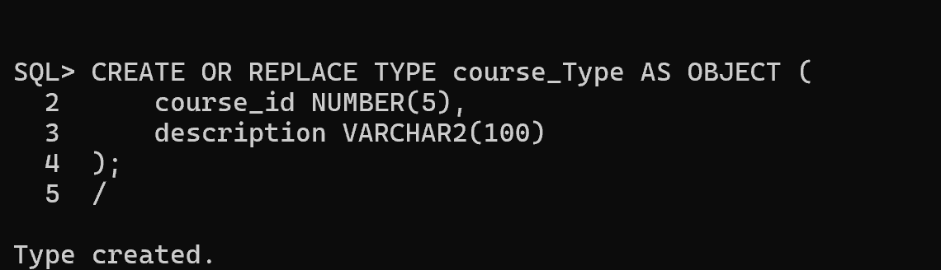

Step 2: Create an Object Table Based on the Type

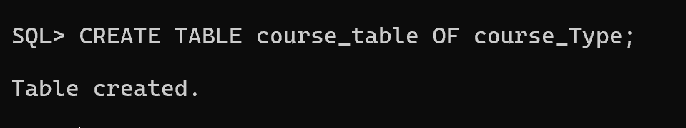

Step 3 -: Insert the rows into the table

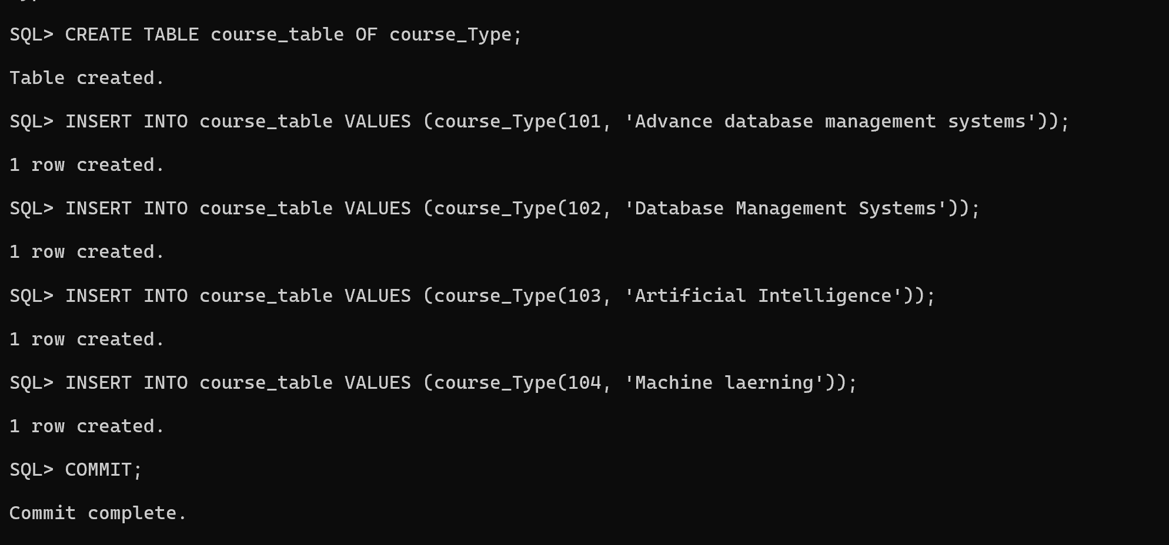

Output -:  
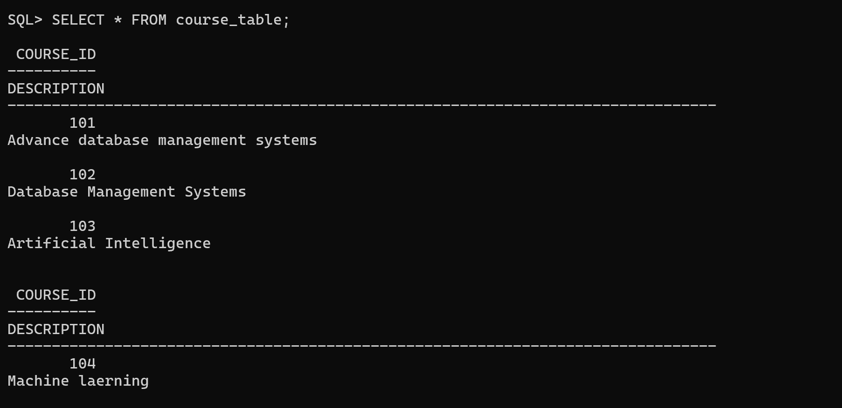

Retrieve specific data =

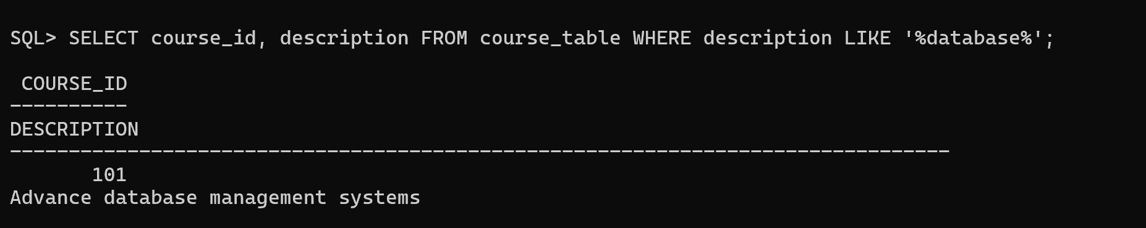

Count the total number of courses =

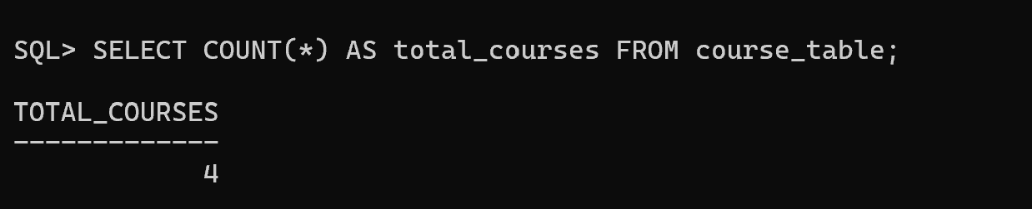

Retrieve the course with specific id=

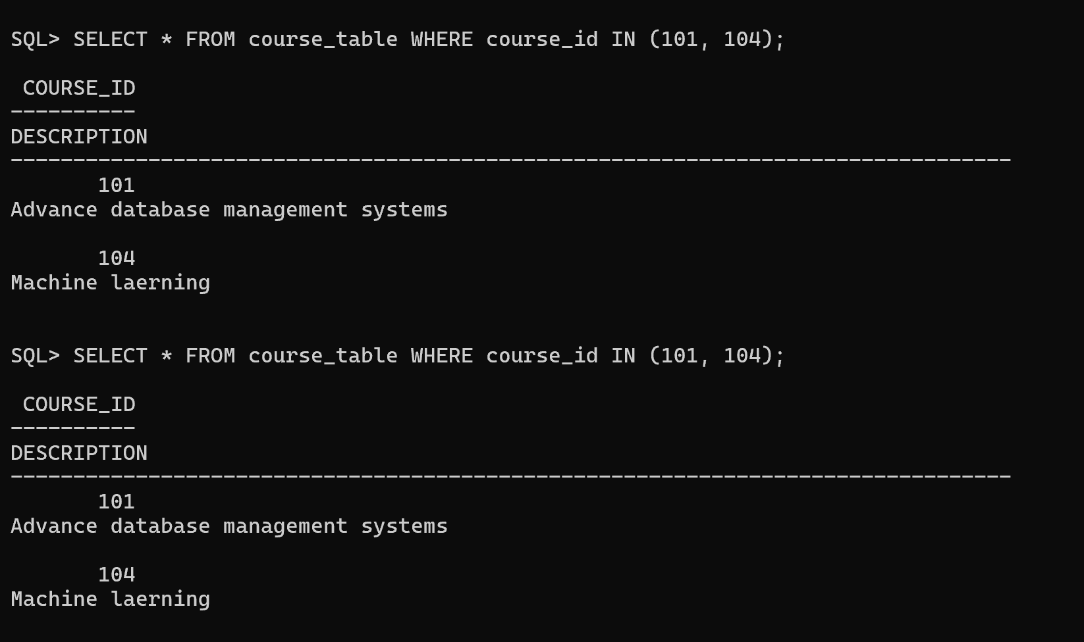

**Conclusion -:** Hence I have studied and performed this practical successfully